

CLIENT: | Thelen CDJR | PHONE #:
SPOT: | THEL-CD-T210302 Truck Month 15 | FAX # :
LENGTH: | :15 | SALES REP: | Larry H.
DATE: | 3/5/2021 | PRODUCER | A. Dennis

GRAPHICS | Video | AUDIO
Thelen Chrysler Logo  Euclid Ave. - Bay City  www.thelenchryslerjeepdodge.com  (Chrysler, Dodge, Jeep, Ram Logos)  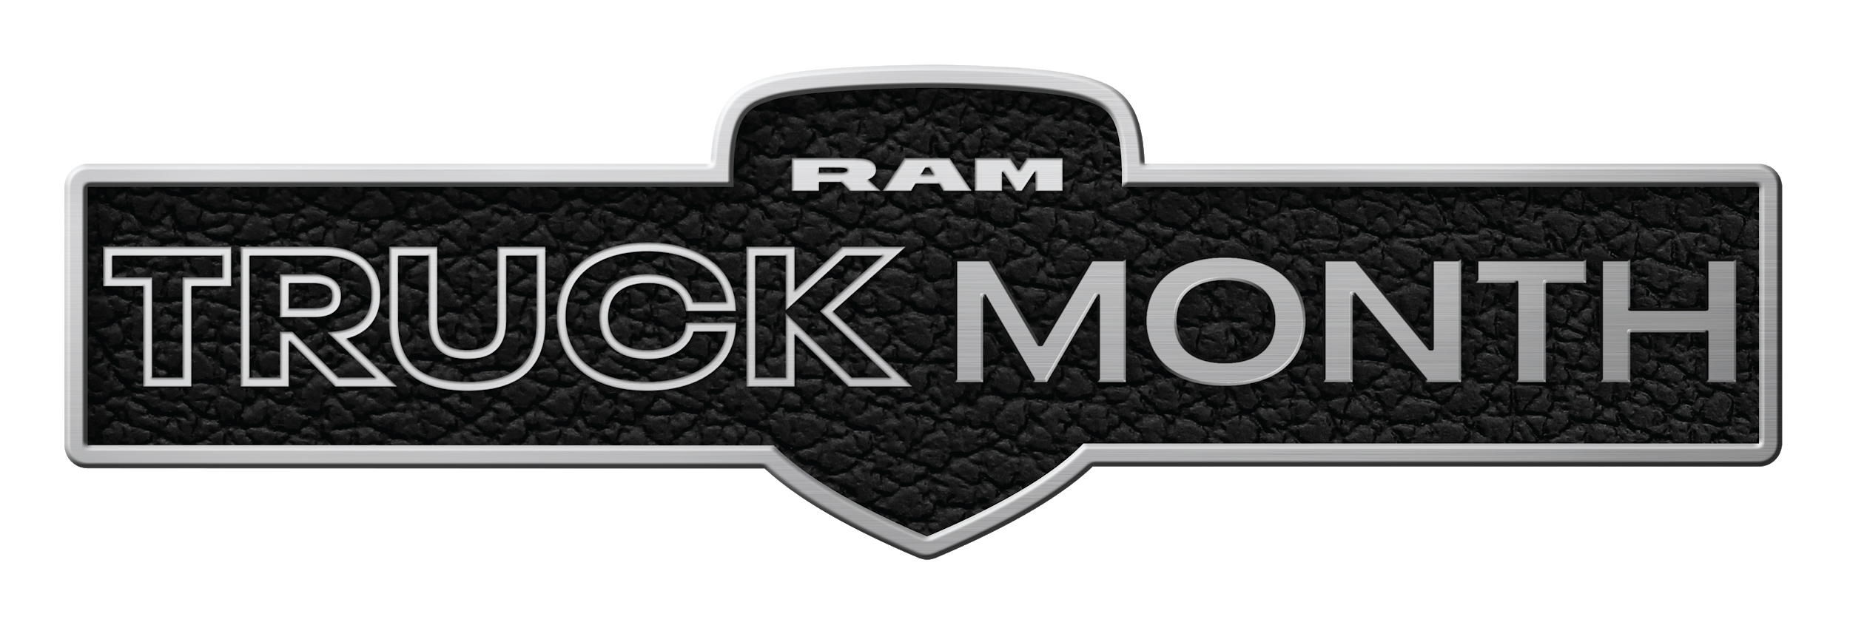  2021 Ram 1500 Big Horn Crew Cab  Lease From Just $309/mo  0% APR for 72 Months  0% APR for 72 months equals $13.89 per $1,000 financed, regardless of down payment, for well qualified buyers with approved credit and financing through Chrysler Capital. Not all customers will qualify. Lease for 36 months, 10,000 miles per year with approved credit. $3,049 down or trade equity due at signing. Tax extra. Must qualify for all available rebates and incentives. Picture may not represent the actual vehicle. Optional equipment shown not included. See Thelen Chrysler for details. Ends March 31st, 2021.  Thelen Chrysler Logo  Euclid Ave. - Bay City  www.thelenchryslerjeepdodge.com  (Chrysler, Dodge, Jeep, Ram Logos) | GFX: 2021 Ram Truck Month (logo)  GFX: 2021 Ram 1500 Big Horn Crew Cab | Announcer: (:15)  Get MORE savings at Thelen Chrysler Dodge Jeep Ram in Bay City!  During Ram Truck Month - lease a new Ram 1500 from just $309 a month! Or choose 0% APR for 72 months!  Now at Thelen Chrysler Dodge Jeep Ram! Euclid avenue, Bay City!
Approved:_______ Approved with Changes: Client Signature: _________________________________

